PREVENTION prepared communities – logistics
St. Joseph Mercy Chelsea's Community Health department is the provider agency of Project Success. Project Success operates in Chelsea, Manchester and Dexter's middle school and high schools within Western Washtenaw County. Our priority areas are to reduce childhood and underage drinking, reduce prescription and over the counter drug abuse/misuse, reduce illicit drug use, and reduce underage vape/e-cigarette use. St. Joseph Mercy's Community Health department, along with the Project Success counselors, Michaela Buckhannon, Lauren Herdrich, and Trista Palmer, work closely with Chelsea School District, Dexter Community Schools, Manchester Community Schools, SRSLY Chelsea, SRSLY Dexter, and SRSLY Manchester, as well as each town's corresponding Wellness Coalitions.

primary problem & associated intervening variables
CMHPSM Priority Area 1: Reducing Childhood and Underage Drinking
The primary problem when it comes to priority area one is that of delinquent behavior. This behavior is often normalized and can make youth think that adults, as well as others support youth alcohol use. Other such risk factors include the ease of access to alcohol, peer pressure to drink, and a lack of perceived risk and harm (negative consequences) when it comes to youth consuming alcohol. Protective factors for reducing underage drinking include problem solving skills, coping skills, clear parental expectations for behavior and values, and positive opportunities for engagement within school, community and family. The target population for reducing childhood and underage drinking are youth and parents in Chelsea, Dexter, and Manchester Michigan.
CMHPSM Priority Area 2: Reducing Prescription and Over-the-Counter Drug Abuse/Misuse
The primary problem in reducing prescription and over the counter drug abuse or misuse is the escalation of data where the national rates pertaining to overdose, injury, death, and addiction are quite high. This makes younger adults and youth think that more people are using in their age demographic than what actually are. Other risk factors include lack of perceived risk and harm of taking prescription medication not as prescribed, norms that support prescription medication use, ease of access to prescription medication, and peer pressure to abuse/misuse it. Protective factors for reducing prescription and over the counter drug abuse/misuse include those listed in priority area one as well as early prevention education on the risks and harm of prescription and over the counter drug abuse/misuse and reducing access by collaborating with ongoing efforts in this area (i.e.: big red barrel, drug take back days, etc.). The targeted population for priority area two are youth and parents in Chelsea, Dexter, and Manchester Michigan.

CMHPSM Priority Area 4: Reducing Illicit Drug Use
The primary problem when it comes to reducing illicit drug use can be seen with the statistics of past 30 day use of marijuana as well as delinquent/problem behavior. Some of the intervening variables of illicit drug use in youth include norms that support illicit drug use, peer pressure, lack of perceived risk and harm of the illicit drug, familial or peer use and marketing of marijuana to youth through mass media. Other risk factors for illicit drug use include the misunderstanding and misperception of the medicalization and legalization of marijuana for recreational use. Protective factors for reducing illicit drug use include prevention education early on, strong family bonds, positive opportunities for engagement within school, community and family, positive coping skills and problem solving skills as well as clear parental expectations for behavior and values. The targeted population for priority area three are youth and parents in Chelsea, Dexter, and Manchester Michigan.

CMHPSM Priority Area 5: SUD Other: Reduce Underage Vape and E-cigarette Use
The primary problem when it comes to reducing electronic cigarettes/vapes among teens are similar to that of priority area one, where it is normalized, accessible, peer pressure to use, and a lack of perceived risks and harm, although this is starting to change. Protective factors for reducing electronic cigarettes and vape use among teens include prevention education to parents, students and community members. It includes problem solving skills, coping skills, clear parental expectations for behavior and values, and positive opportunities for engagement within school, community and the family.

evidence based intervention/initiative & Csap strategies
Project Success has been implemented in Manchester for ten years, in Chelsea for four years and in Dexter for one year. It is an evidence based program that prevents and reduces adolescent substance use and abuse. It places a Project Success Counselor in Chelsea, Manchester and Dexter's High School and Middle School to provide: individual and group counseling, prevention and drug education, training/consultation on prevention issues, coordination of substance abuse services and policies of the school, and referral/follow-up services with students and families needing substance abuse treatment or mental health services in the community. Project Success uses these universal, indirect and direct interventions to decrease factors that put students at risk of substance use and to increase factors that protect students.
Project SUCCESS Program Components
- The Prevention Education Series (PES), provides up to eight sessions on alcohol, tobacco, and other drug education available to the schools to be used in health, PE, science or other classroom settings.

- Individual and group counseling sessions where students learn how to identify and resist pressures to use substances, correct misperceptions about the prevalence and acceptability of substance use, and understand the consequences/risk of substance use
- School-wide activities and promotional materials to increase the perception of the harm of substance use, positively change social norms about substance use, and increase enforcement of and compliance with school policies.
- Teacher, parent and community education on various substances youth use and what resources are available to help with this (alcohol, tobacco, marijuana, e-cigarettes, prescription drug abuse and other drugs).
- Screening and referral for treatment in which students and parents who require more intensive counseling, treatment, or other services are referred to appropriate agencies or practitioners in the community.
- Positive Social Norming campaign to help students realize most of their peers are not using Alcohol, Tobacco, or Other Drugs (ATOD). Two years ago, the social norming campaign was rebranded as "SRSLY? Check Your Stats" and included an online social media campaign, as well as additional information on vaping, and protective factors (students involved in clubs, students who approve of their friends being drug-free, and students who do fun things with their parents). These posters were hung around the schools and community, as well as used with a monthly theme along with the SRSLY "Check In With Us" held once a month at lunch at the schools prior to school closure due to COVID-19. These ads were then created into social media posts, videos and paid ads on Instagram and Facebook through the SRSLY Coalition in each of the corresponding towns.
The Project SUCCESS program utilizes the Center for Substance Abuse Prevention (CSAP) intervention strategies of information dissemination, education, problem identification and referral, community based process, environmental and alternatives.

outcomes/results

In addition to targeting all Chelsea, Dexter and Manchester's high school and middle school youth with prevention messages, campaigns, and activities- a total of 87 (42 Chelsea students, 7 Dexter students, and 38 Manchester students) high school and middle school students met with a Project SUCCESS Counselor for individual counseling during the 2019-20 school year. During these meetings, students were provided resources and referrals to address their individual needs.

Forty students (24 Chelsea students, 0 Dexter students, and 16 Manchester students) participated in the Project SUCCESS group counseling services. Nineteen students (14 Chelsea students, 0 Dexter students, and 5 Manchester students) met for up to eight ongoing individual counseling sessions and also completed a post-test assessing their perceptions of risk and harm when it comes to youth use of alcohol, nicotine/tobacco, marijuana and abuse of prescription medication. The breakdown of these services are in the appendices below (appendices 3-8).
The majority of students from each school reported a higher awareness of risk for teen ATOD use after completing the individual ongoing meetings, however, from the last year to this year we do continue to see a reduction in the number of students reporting marijuana as harmful and risky for both group and individual services. When we compare student's perception of harm, we see that the same students who completed individual ongoing sessions saw marijuana as being less harmful than alcohol and prescription medication abuse (see appendices 3-5). This reduction in perception of risk and harm of marijuana is consistent even when we look at long-term data from the Michigan Profile for Healthy Youth survey (MiPHY) (see appendix 2).
Connecting our program outcomes with the results for the MiPHY survey from 2020 for Chelsea, Dexter, and Manchester's high school students, we see that the rate of use has dropped significantly from 2007 until now (see appendix 1). In Manchester, where they have had a Project Success program consistently for the past ten years, the rate of recent use for alcohol, marijuana and prescription medication have all declined since 2016 until 2018, whereas in Chelsea where Project Success has been in place on and off for a period of four years, the rate of recent use has either become stagnant or increased ever so slightly. In Dexter, where the Project SUCCESS program has been in place for one year, there is not yet enough data to see the long-term trend. The data that is available to our program is from the 2018 MiPHY (appendix 1 and 2). It would seem that the prevention efforts of both SRSLY and Project Success in these middle schools and high schools appear to be making an impact on our priority areas of reducing childhood and underage drinking, reducing prescription and over the counter drug abuse/misuse, reducing illicit drug use, and reducing underage vape/e-cigarette use.

Appendix 1
Appendix 1 Narrative:
These graphs depict the self-reported use of alcohol, marijuana and prescription drug abuse over the course of the high school student's life time, as well as recent use, defined as use in the last 30 days. The survey data is from the Michigan Profile for Healthy Youth (MiPHY). The MiPHY data reports were made available through each school district. These tables are from Chelsea, Manchester and Dexter high schools.
Dexter High School Trend Data – MiPHY 2018
Manchester High School Trend Data – MiPHY 2020
Chelsea High School Trend Data – MiPHY 2020

Appendix 2:
Appendix 2 Narrative:
These graphs depict the perception of risk that high school students report from the Michigan Profile for Healthy Youth data (MiPHY) The MiPHY data reported here is the most recent reports available through each school district. These tables are from Chelsea, Manchester and Dexter high school students responses to the risk of regular use (in the last 30 days) of the following substance (alcohol, marijuana and prescription drug abuse).

Chelsea High School Perception of Risk – MiPHY 2020
Dexter High School Perception of Risk Data - MiPHY18
Manchester High School Perception of Risk Data – MiPHY20

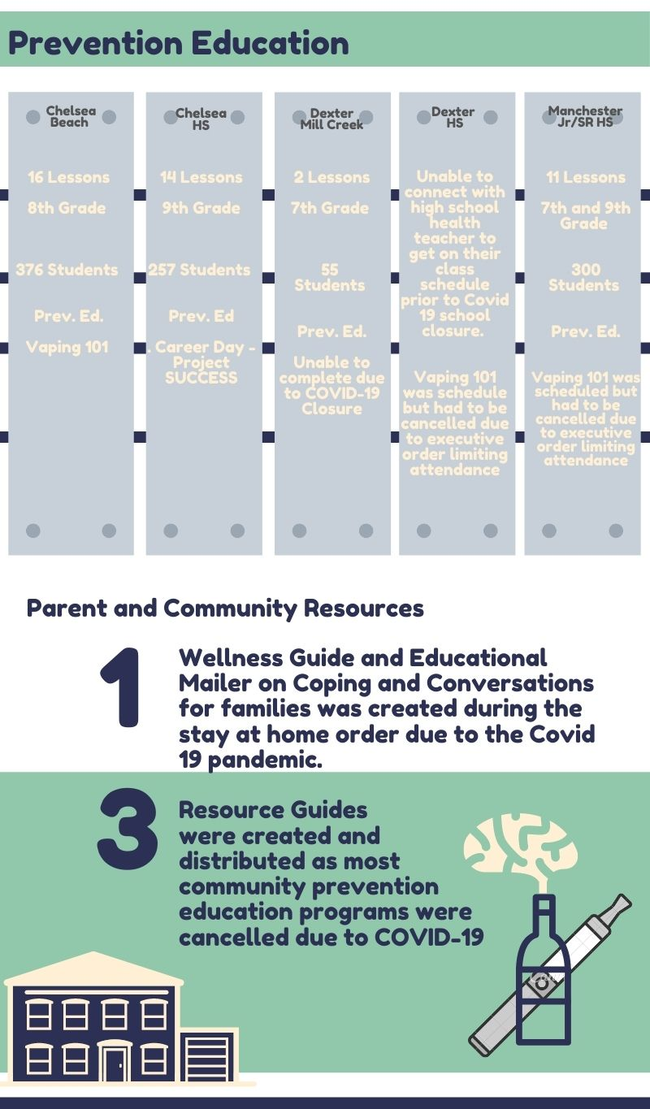
Appendix 3

The following infographic displays the Project SUCCESS student assistance efforts to implement the Prevention Education two-lesson series on vaping, addiction, brain development, risk and harm of ATOD use, and how to handle peer pressure, in coordination with the Chelsea, Dexter and Manchester school districts.
It depicts the parent and community resources that were created and distributed through the SRSLY Regional Coalition's webpage, newsletter, and social media pages in Chelsea, Dexter and Manchester from March of 2020 through September 2020 as all live community events previously scheduled had been cancelled due to the stay-at-home order.

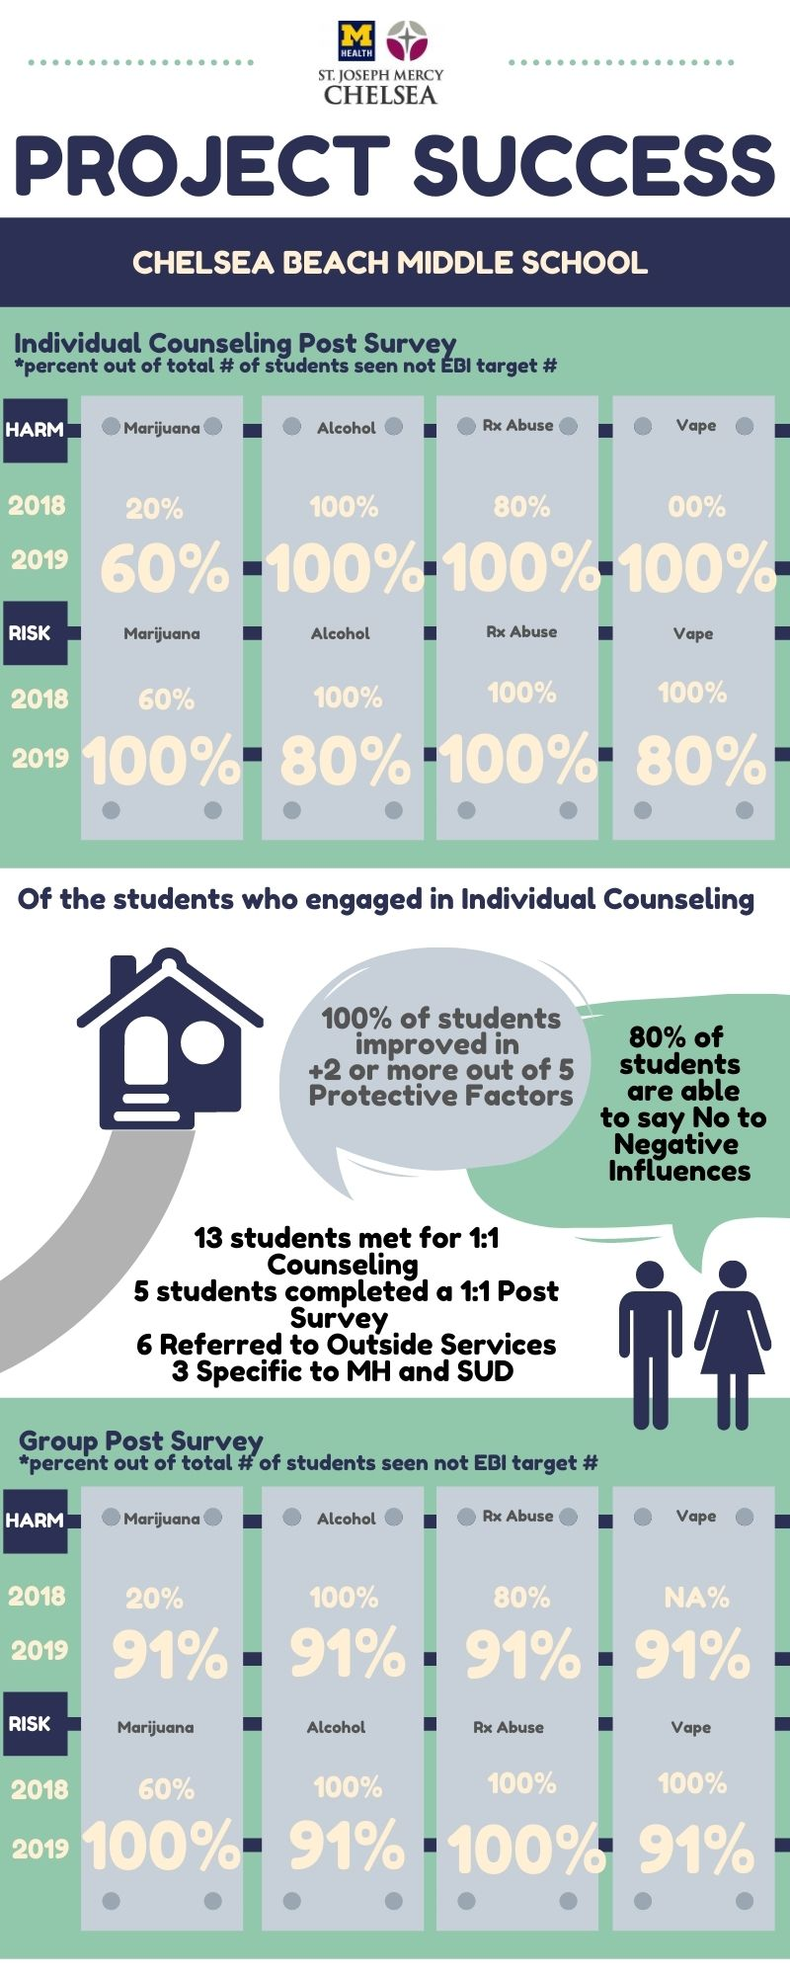Appendix 4:
Beach Middle School:
Of the students who completed individual ongoing counseling sessions (n=5):
- 80% reported improved relationships at schools
- 80% reported improvement in their ability to say no in situations of peer pressure
- 100% of students reported improving in two or more of the following protective factors: improved relationships, ability to say no to negative influences, ability to handle feelings, ability to handle problems in life, or made a change to stop ATOD use or have not used.
Of the students who completed participation in the group sessions (n=11):
- 72% reported improved relationships at schools
- 100% reported improvement in their ability to say no in situations of peer pressure
- 100% of students reported improving in two or more of the following protective factors: improved relationships, ability to say no to negative influences, ability to handle feelings, ability to handle problems in life, or made a change to stop ATOD use or have not used.
For universal prevention education in the classrooms, 376 students at Beach Middle school took part in a two-session unit on vaping, addiction, brain development, risk and harm of ATOD use, and how to handle peer pressure.

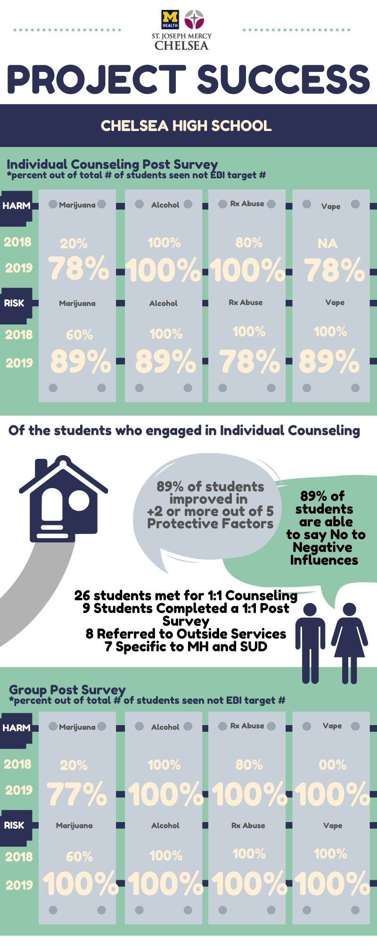
Appendix 5:
Chelsea High School:
Of the students who completed individual ongoing counseling sessions (n=9):
- 45% reported improved relationships at schools
- 89% reported improvement in their ability to say no in situations of peer pressure
- 89% of students reported improving in two or more of the following protective factors: improved relationships, ability to say no to negative influences, ability to handle feelings, ability to handle problems in life, or made a change to stop ATOD use or have not used.
Of the students who completed participation in the group sessions (n=13):
- 85% reported improved relationships at schools
- 85% reported improvement in their ability to say no in situations of peer pressure
- 92% of students reported improving in two or more of the following protective factors: improved relationships, ability to say no to negative influences, ability to handle feelings, ability to handle problems in life, or made a change to stop ATOD use or have not used.
For universal prevention education in the classrooms, 257 students at Chelsea high school took part in a two-session unit on emotional regulation, stress management, addiction, teenage development, risk and harm of ATOD use, and how to handle peer pressure

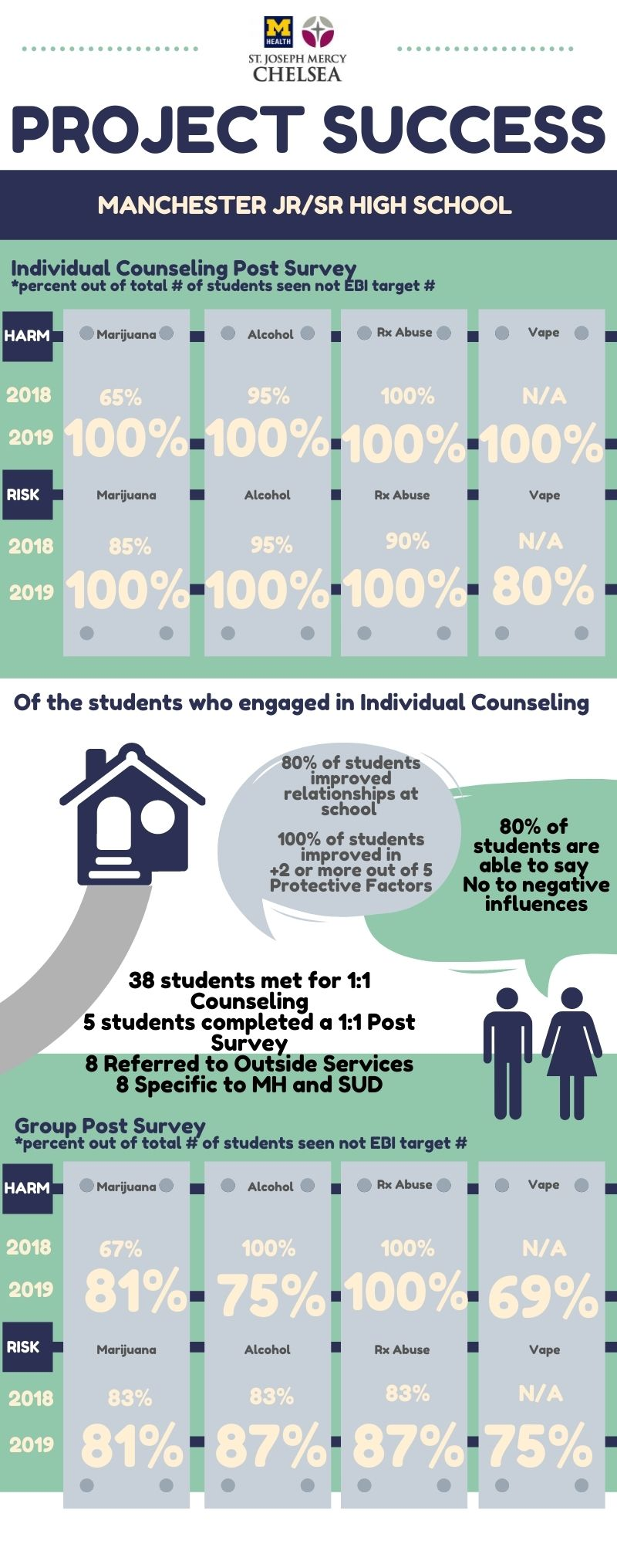
Appendix 6:
Manchester Middle School and High School:
Of the students who completed participation in the ongoing individual sessions (n=5)
- 80% reported improved relationships at schools
- 80% reported improvement in their ability to say no in situations of peer pressure
- 100% of students reported improving in two or more of the following protective factors: improved relationships, ability to say no to negative influences, ability to handle feelings, ability to handle problems in life, or made a change to stop ATOD use or have not used.
Of the students who completed participation in the group sessions (n=16):
- 73% reported improved relationships at schools
- 73% reported improvement in their ability to say no in situations of peer pressure
- 100% of students reported improving in two or more of the following protective factors: improved relationships, ability to say no to negative influences, ability to handle feelings, ability to handle problems in life, or made a change to stop ATOD use or have not used.
For universal prevention education in the classrooms, 341 students at Manchester middle school and high school took part in a two-session lesson on emotional regulation, stress management, addiction, teenage development, risk and harm of ATOD use, and how to handle peer pressure.
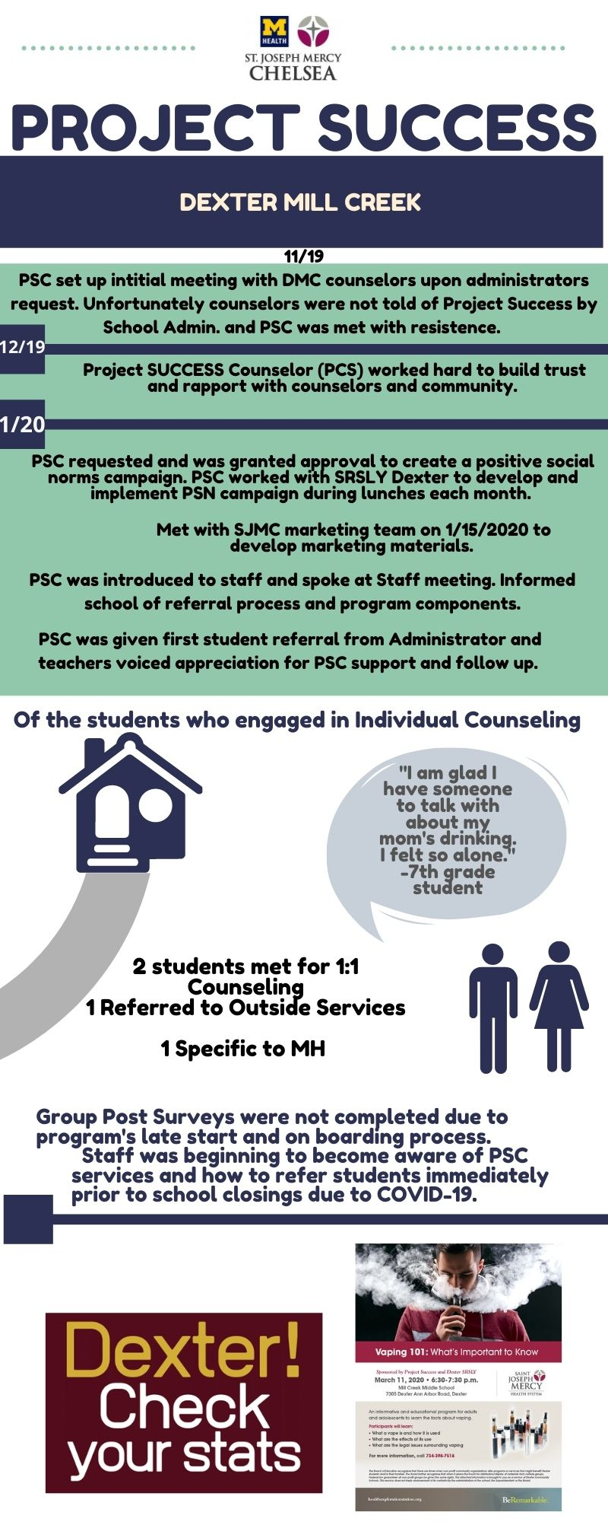
Appendix 7:
Dexter Mill Creek Middle School:

Positive Social Norms campaigns and relationship building in each community were a major focus of the program. Community Education for both DMC and DHS students and families was planned, organized and scheduled for March 11, 2020. The event itself had to be cancelled however, due to the spread of the COVID-19 pandemic.
Of the 7 students who met for individual ongoing counseling, (5 at DHS and 2 at DMC), 6 wanted to continue receiving services and voiced interest in groups. Unfortunately, due to COVID-19, groups were not able to be formed during the school year.
For universal prevention education in the classrooms, 55 Dexter Mill Creek students took part in a one session unit on addiction, teenage development, risk and harm of ATOD use, and how to handle peer pressure.
78%

PSC attended team meetings with middle school staff to discuss students at risk that may be suitable for groups prior to school closing.

PSC attended student lunch periods at both DMC and DHS on a rotating schedule to get to know staff and become a visible part of the school community.

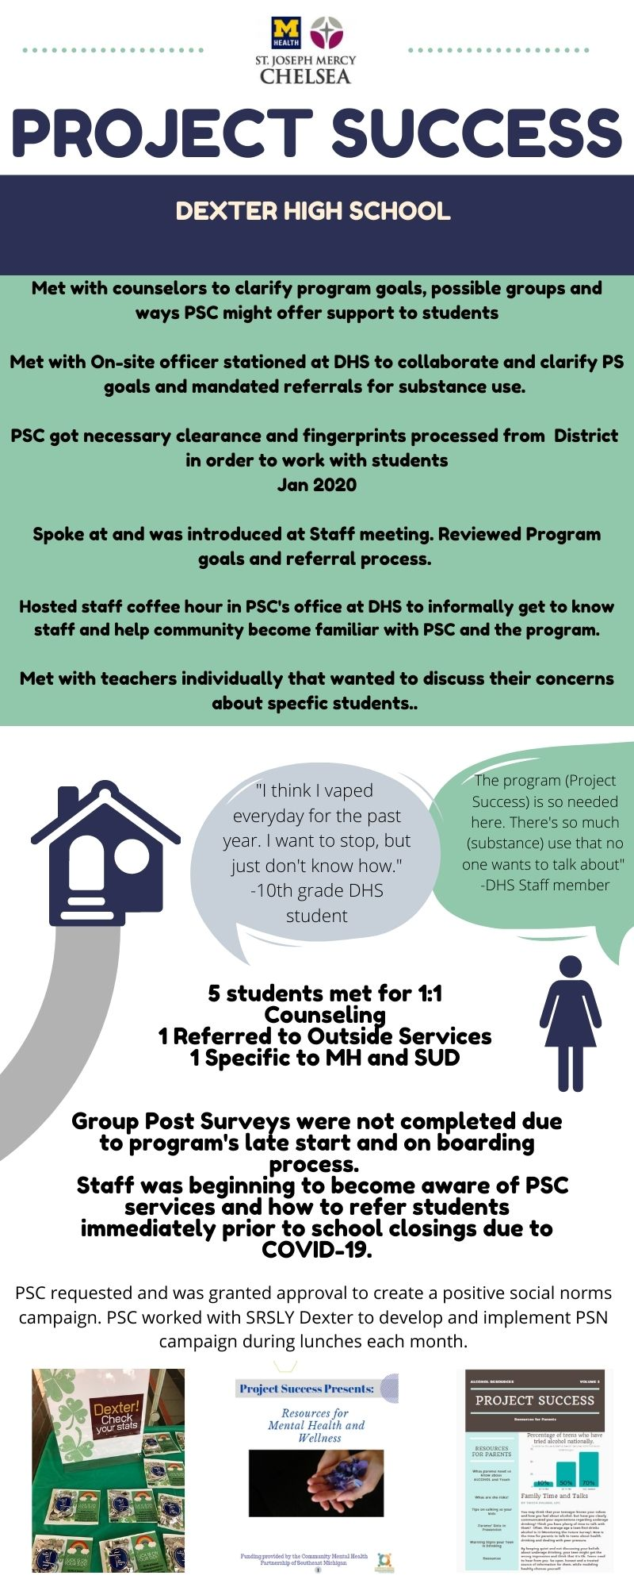
Appendix 8:

Dexter High School:
Parents of students who participated in individual ongoing counseling that were contacted were receptive and open to services.
For universal prevention education in the classrooms, high school health teachers were contacted prior to the COVID school closures to collaborate. Unfortunately, Prevention Education was not facilitated in the high school.
78%
PSC attended CADCA week-long SPF training in NC with SRSLY Dexter March 1-6, 2020.
Schools closed: March 13, 2020
PSC team continued to discuss how to meet students' needs virtually if telehealth services were not possible.
In addition to district mailers, an online Wellness Guide for students and parents was created in lieu of in-person prevention education to provide resources and support re: mental health and coping issues.
Parent Resources on Vaping, Alcohol and Marijuana were created and published on SRSLY websites.
PSC continued to study for the IC&RC CPS exam and participated in numerous Continuing Education opportunities for MCBAP requirements, as well as weekly supervision hours.

