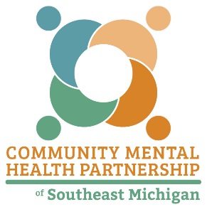
COMMUNITY MENTAL HEALTH PARTNERSHIP OF SOUTHEAST MICHIGAN

SUBSTANCE USE DISORDER PREVENTION PROGRAMS
FY 2020-2021

Prevention Provider | County | Evidence-Based Program
Catholic Social Services of Washtenaw County | Washtenaw | Get Connected  CAGE Screening
Catholic Charities of Southeast Michigan | Monroe | Student Prevention Leadership Teams
Eastern Michigan University | Washtenaw | Prevention Theatre Collective  Botvin LifeSkills Training Transitions
Karen Bergbower and Associates | Lenawee  Livingston  Monroe  Washtenaw | Designated Youth Tobacco Use Representative  Regional Vaping Prevention Initiative
Livingston COMMUNITY PREVENTION Project:  Livingston County Catholic Charities  Karen Bergbower & Associates  Key Development Center | Livingston | Communities Mobilizing for Change on Alcohol  Curriculum-Based Support Group  MOST Teens Don’t – Social Norming Campaign  Project SUCCESS  Safe Homes  Youth Led Prevention  Youth Photovoice
Monroe County Intermediate School District | Monroe | Nurturing Parenting/Parents As Teacher
St. Joseph Mercy – Chelsea | Washtenaw | Project SUCCESS
United Way of Lenawee & Monroe Counties | Monroe | Monroe County Substance Abuse Coalition  CADCA Strategies for Community Change

