CMHPSM
This guide is intended to be a resource for both internal CMHSP staff and external provider staff.
CMHPSM Regional Unlicensed CLS Guide
Version 1.0 Revised:5/17/17

Table of Contents
CMHPSM Regional CLS Guide 3
A. CLS Authorized Site Plan H0043 3
B. Directly Authorized H2015 3
C. Directly Authorized H0043 3
CLS Authorization Options Chart 4
CLS Authorization for Site Plan H0043 5
What’s New in Site Plan CLS (July 1, 2017) 5
Quick Links 5
CMHSP Provider Management Setup 6
CMHSP Fee Schedule Setup Guide 6
System Calculated Modifiers 8
CMHSP Authorization Guide 9
Site Plan Authorized Daily Staffing Hours 9
Network Provider Guide 10
Entering CLS Invoices (allowed one submission per month ONLY) 10
New CLS Invoice Sections 11
Site Plan Authorization Section 12
View Site Plan 12
Site Staff Hours Section 13
Consumer CLS Hours Section 13
Consumer Financial & Encounter Information Section 15
H0043 Site Plan Vs H2015 Site Plan Reimbursement 19
CMHSP Claims Payment 20
Direct Authorization for H2015 21
What’s New in Direct Authorization H2015 CLS (July 1, 2017) 21
Quick Links 21
CMHSP Setup 22
CMHSP Fee Schedule Setup Guide 22
CMHSP Authorization Guide 23
Network Provider Guide 23
CMHSP Claims Payment 23
Direct Authorization for H0043 24
What’s New in Direct Authorization H2015 CLS (July 1, 2017) 24
Quick Links 24
CMHSP Fee Schedule Setup Guide 25
CMHSP Authorization Guide 26
Network Provider Guide 26
CMHSP Claims Payment 26
Appendix A: General Information on Community Living Supports 27
Community Living Supports Definition 27
Reference: 28
Appendix B. Old Site Plan Document Blank 29
Appendix C. New Site Plan Document 30
Appendix D. Site Reimbursement Estimator 31

CMHPSM Regional CLS Guide
The CMHPSM region was required to transition unlicensed CLS service encounter reporting from H2015 to H0043 for the vast majority of consumers during 2017. It was determined that the most consistent, least disruptive manner to do this was to revise the CLS site plan model to export H0043 data rather than H2015 data. In addition to this encounter data revision, the CMHPSM region determined that a number of revisions and updates could be made to increase the efficiency and effectiveness of the CLS site plan model. This guide was developed to document the setup, authorization, billing and claims payment information related to the unlicensed CLS models being utilized within the region.
The CMHPSM currently has three different options for authorizing unlicensed CLS service. All three options will be covered within this CLS guide.

CLS Authorized Site Plan H0043
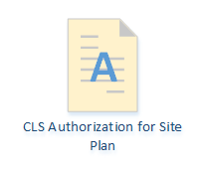
The CMHPSM region created a unique site plan based system to reimburse unlicensed CLS service providers in 2008. In 2017, the CMHPSM transitioned the site plan encounters from H2015 to H0043 and revised the CLS invoice system.
This option is used most frequently within the CMHPSM region to authorize unlicensed CLS services.

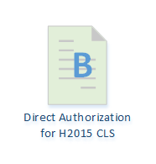
Directly Authorized H2015
This option is not used as frequently as site plan CLS, but may be used to authorize for unlicensed CLS for consumers as indicated in the diagram found on the next page.

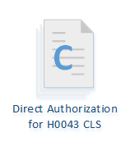
Directly Authorized H0043
This option is rarely used within the CMHPSM region, but may be used to authorize for unlicensed CLS for consumers as indicated in the diagram found on the following page.

The CLS authorization options chart on the following page will determine the CLS authorization type for most CLS consumers. The CMHSP reserves the right to determine the CLS authorization option for each consumer to best meet the needs of the consumer, payer and provider.

CLS Authorization Options Chart

CLS Authorization for Site Plan H0043

What’s New in Site Plan CLS (July 1, 2017)
For CMHSPs:
H0043 per diem code replaces H2015 for encounter data derived from site plan CLS.
Fee schedule changes and new modifiers.
Home help is deducted across all days of service rather than the first days of the month.
For Providers:
CLS site plan document quick link added for billers on site plan invoice.
Billing for site plan service no more frequently than monthly, and all site plans will be one full month.
No reimbursement change for providers from the H2015 site plan model to H0043 site plan model. Hourly staffing reimbursement stays the same.
Less complicated data entry required for site plan invoice.

Quick Links
Quick Link to CMHSP Provider Management Staff Section for Site Plan H0043
Quick Link to CMHSP Authorizing Staff Section for Site Plan H0043
Quick Link to Provider Section for CLS Site Plan H0043
Quick Link to CMHSP Claims Payment Staff Section for CLS Site Plan H0043

CMHSP Provider Management Setup

CMHSP Fee Schedule Setup Guide
Fee Schedules for CLS Authorization for Site Plans should be housed within the Supported Living Site Plan contract type for each provider as pictured below:
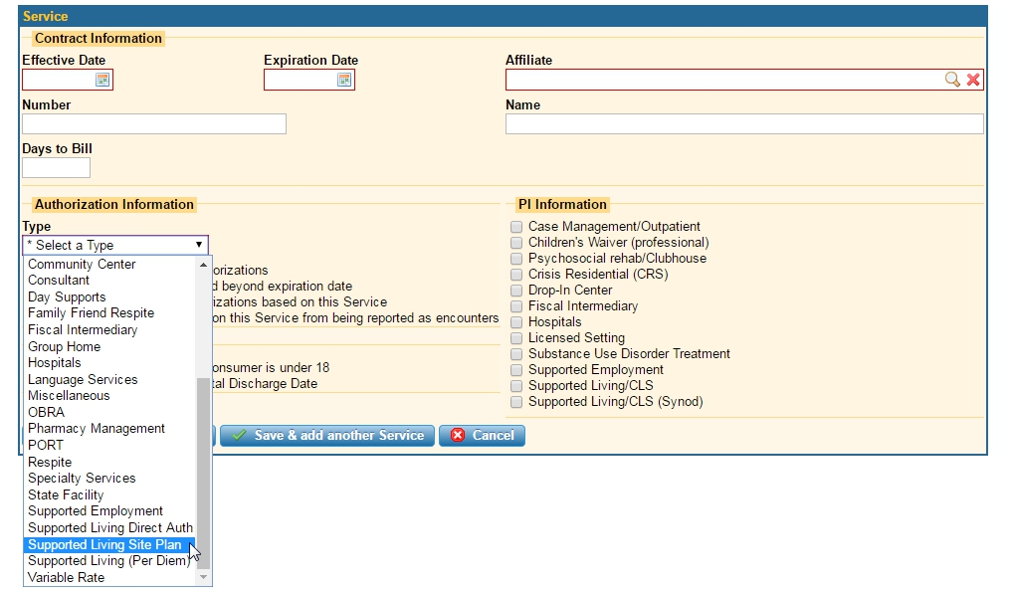
The fee schedules for each provider should be setup within the Supported Living Site Plan contract type as depicted below:
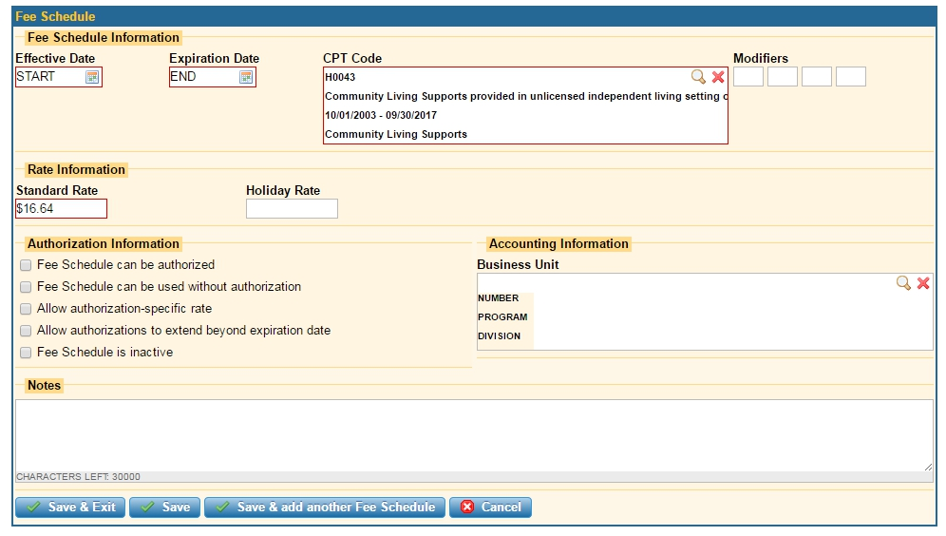

- Enter the current hourly service rate in the standard rate field. This rate is used to calculate the custom per diem for each consumer that is on a CLS site plan.
- The CLS site plan module will calculate all reimbursement utilizing this rate, and this rate must tie to the hourly reimbursement level in the provider’s contract with the CMHSP.
- Note that no authorization information fields need to be checked for provider reimbursement to occur. CLS Authorizations and site plans are utilized to ensure proper reimbursement not traditional authorizations.
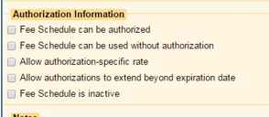
- Site plan reimbursement will only occur when a fee schedule effective and expiration date covers the entire CLS invoice being submitted.
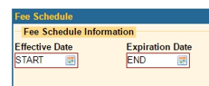
- Beginning with reimbursement for services occurring on June 1, 2017 all CLS site plan service will utilize H0043. The system will add all of the appropriate modifiers based upon service data.
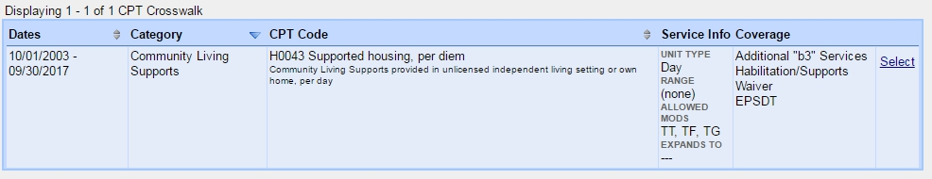

The following fee schedules should be entered for each CLS provider:
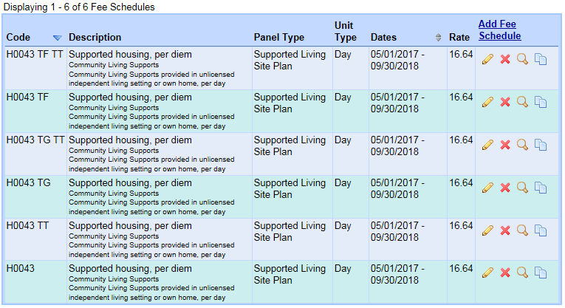

System Calculated Modifiers
Modifiers are automatically added to the CLS encounters for the entire month based upon the following guidelines:
Intensity Modifier | Average CLS Hours Per Day Served
No | Less than 3.0
TF | 3.0 – 10.0
TG | More than 10.0

Shared Status Modifier | # of Consumers
No | Only one consumer has service entered on a CLS invoice related to a CLS site.
TT | Two or more consumers have service entered on one CLS invoice related to a CLS site.

H0043 | H0043 TT | H0043 TF | H0043 TG | H0043 TF TT* | H0043 TG TT*
*Please note the order of the modifiers when multiple modifiers are entered into the fee-schedules. The TF or TG needs to be the primary modifier as TT needs to be the secondary modifier.

CMHSP Authorization Guide
CLS Authorization for H0043 Site Plans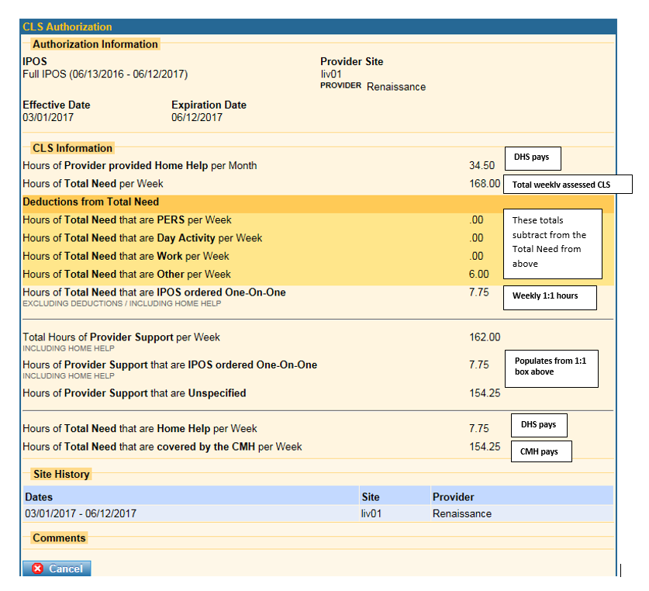

Site Plan Authorized Daily Staffing Hours
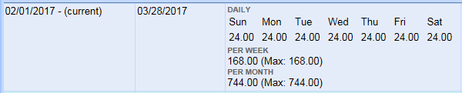

Network Provider Guide
Providers contracted with one or more of the CMHSPs within the CMHPSM region to provide CLS service will predominantly be issued CLS site plan authorizations. The following guide relates to CLS site plan authorized CLS provision.

Entering CLS Invoices (allowed one submission per month ONLY)
To Enter Monthly Billings select View CLS Invoices from the:
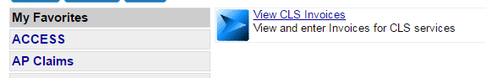

Then select add CLS Invoice:
Which will open the following CLS Invoice screen:
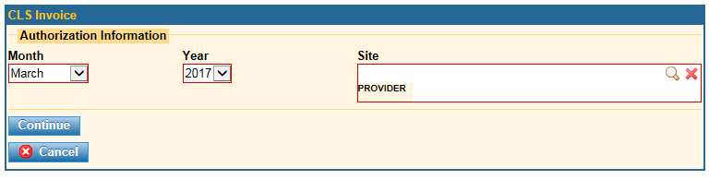
Then select Month, Year and Provider site of the service you are attempting to bill for and then click continue:

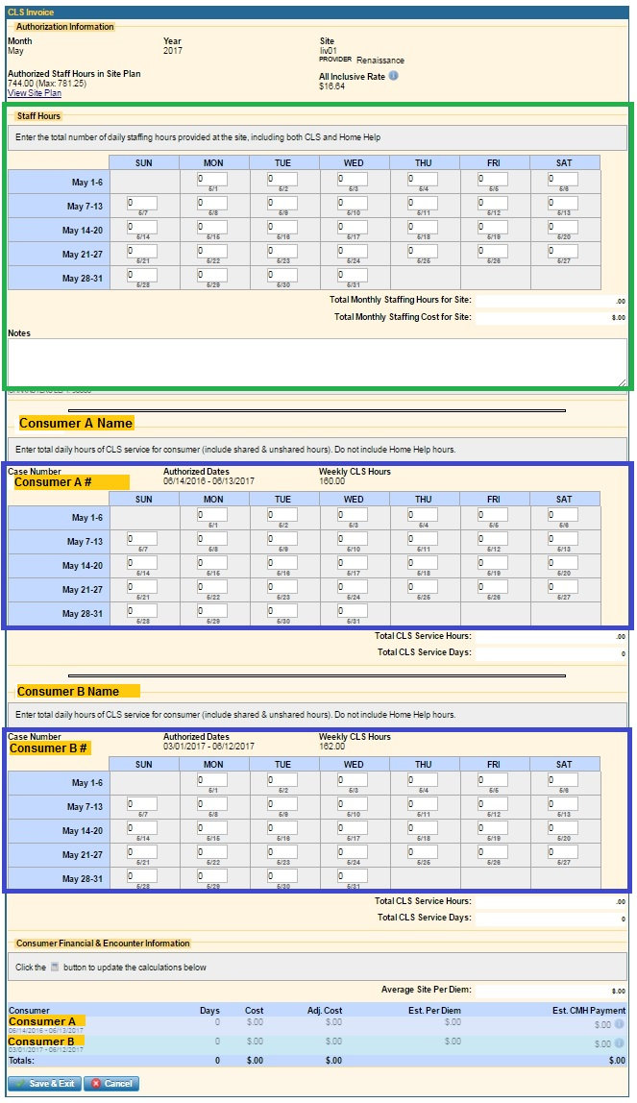
New CLS Invoice Sections
Site Plan Authorization Section

View Site Plan Button

Total Site Staff Hours Section
Enter CLS and Home Help Staffing Time Provided at Site

Consumer A
CLS Hours Section

Enter only CLS hours delivered to Consumer A

Consumer B
CLS Hours Section

Enter only CLS hours delivered to Consumer B

Consumer Financial & Encounter Information Section

Site Plan Authorization Section
The top portion of the invoice identifies the month, year, provider site, authorized staffing hours and hourly CLS reimbursement rate.

View Site Plan
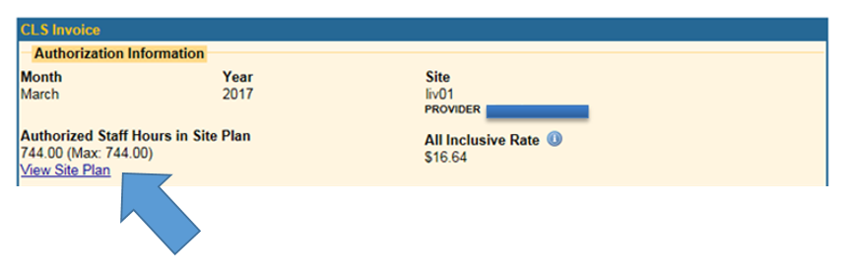
Please note the arrow which shows the link which allows the biller to view the current active site plan.
When you click on you will see the following site plan information screen:
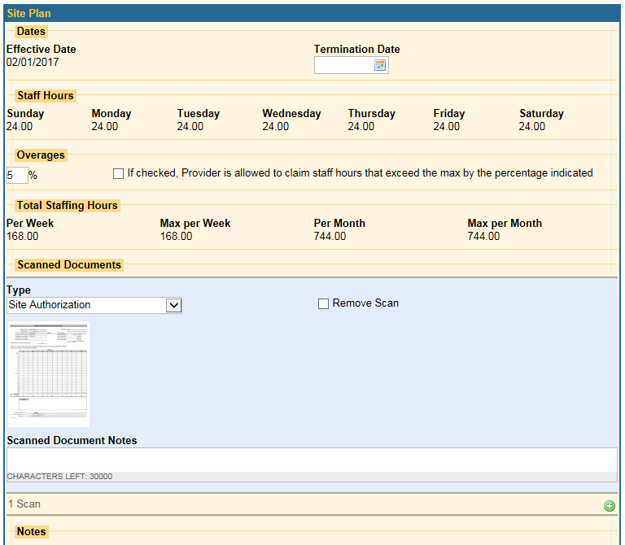

Providers will also be able to view the most recently uploaded/scanned site plan for the site by following the scanned document icon that will be present whenever a scanned site plan document is present in the system. (Please note the sample scanned document section is empty in this example.

Site Staff Hours Section
The next section of the CLS invoice which is labeled staff hours, is used to report total staffing hours provided at the site.
The calendar within the Staff Hours section will reflect the total number of staffing hours associated with both CMHSP funded unlicensed CLS service hours as well as MDHHS funded Home Help service hours.
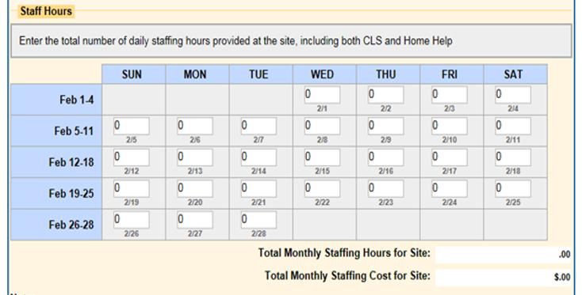
There is also a field for notes within the staff hours section which can be used to provide additional information to CMHSP claims payment staff persons.
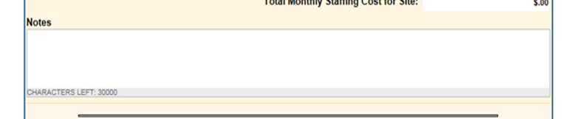

Consumer CLS Hours Section
Below the notes field the CLS invoice screen is customized based upon the number of consumers that our served at a particular unlicensed CLS site. In this example we have a site where two consumers are being served at one site. We have identified these consumers in this example as Consumer A and Consumer B.

As of 7/1/2017 the CMHSPs have streamlined the CLS invoice and no longer require reporting of shared versus unshared hours independently.
- The provider should enter the total daily hours of only CMHSP funded CLS service whether it is shared or unshared.
- There should also be no MDHHS authorized Home Help service hours included in the consumer CLS sections of the invoices.
- Enter zero minutes for any day in which the consumer does not receive at least 15 minutes of CLS service.
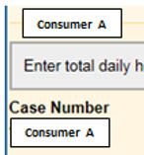
The consumer’s name and EHR case number will be displayed above CLS service hour calendar for each consumer authorized for services at this site.

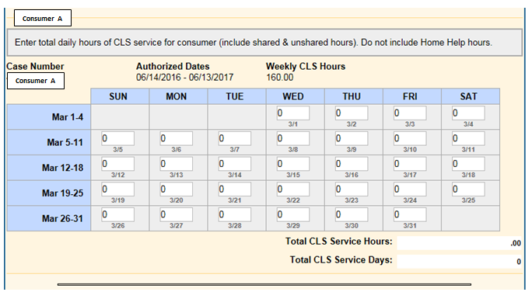
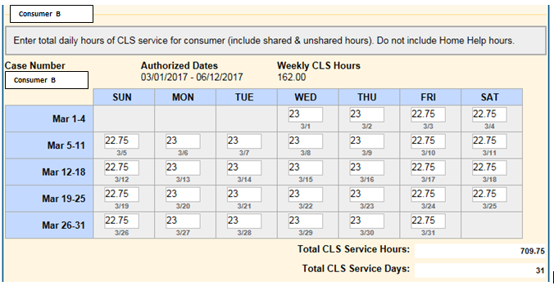

Consumer Financial & Encounter Information Section
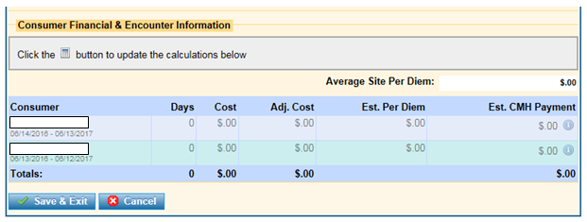
Once all total staffing and consumer CLS calendars are filled out, users must click in order to get above to view the calculations.
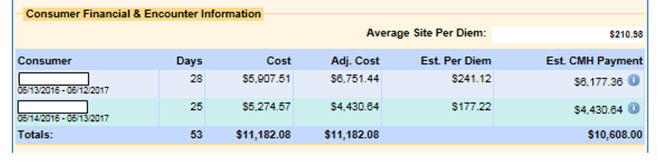
Hovering over the in the Est. CMH Payment column will show the service encounters and the breakdown between CLS and Home Help service payments.
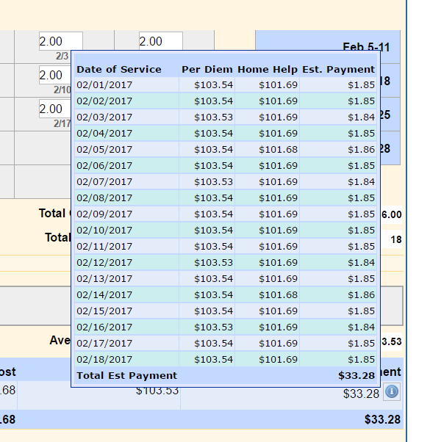
Please note:
- The MDHHS funded Home Help Hours will be deducted from the staffing hours eligible for reimbursement.
- Please note that MDHHS pays a lesser rate than the CMHPSM region on an hourly basis. While the deduction of Home Help service hours should correlate with what MDHHS authorizes your provider agency to provide on an hourly basis, the reimbursement amount resulting from those Home Help hours will be exaggerated in the CLS invoice as we don’t calculate Home Help at the MDHHS rate in our system.

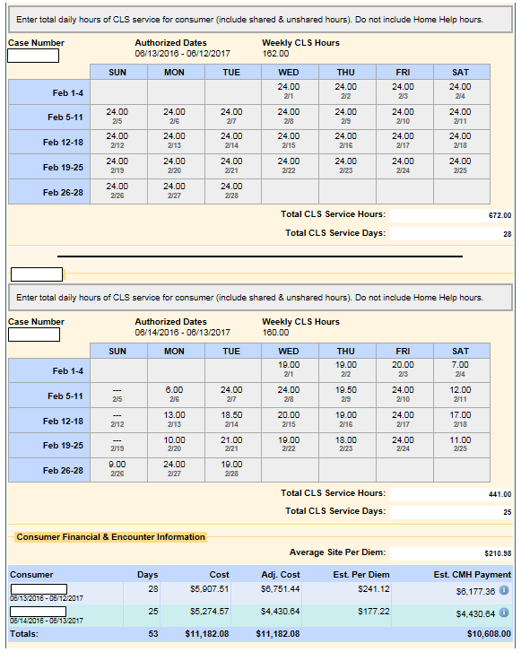
Then Click Save & Exit
If you get this error it means the hours have exceeded the site plan hours. So you do not have to re-enter everything just tweak a day to get it to accept and contact your local CMH. Then you will have to go back to this CLS invoice and possibly make corrections.
If you get the yellow message/warning it just means that one of the days was entered with more than 24 hours. It is possible to have more than 24 hours of staffing in a day due double staffing. Add a note if this is not a common occurrence for this site. Then click Save & Exit again.

After you clicked Save and Exit you will come back to this which is where you can make changes, delete, or view. Please do not send batch to CMH from this point. See next step.
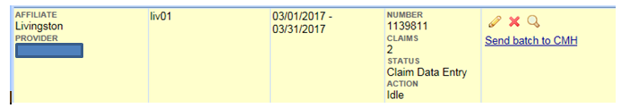
Go back to 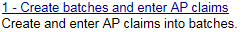
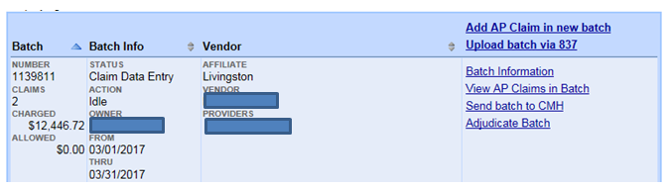
Click Adjudicate Batch so you can be sure there are no errors. If after adjudication you show an allowed amount that is not matching what you expect to get paid you should click on View AP Claims in Batch and review possible errors. If the allowed amount is as expected then click Send batch to CMH.

When you view AP Claims in the batch they will now have the H0043 code along with modifiers that are being attached automatically based on the CLS Invoice that was submitted.
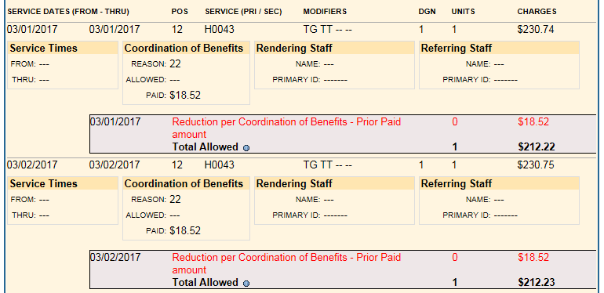

The deductions above are based on an individual that receives Home Help and this deduction matches what you currently see on your claims.
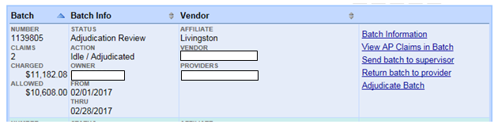
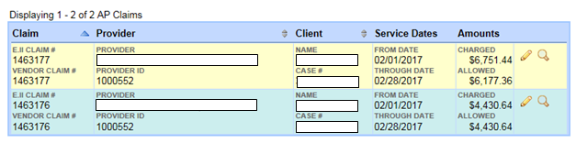

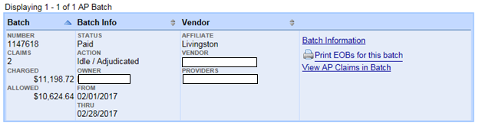
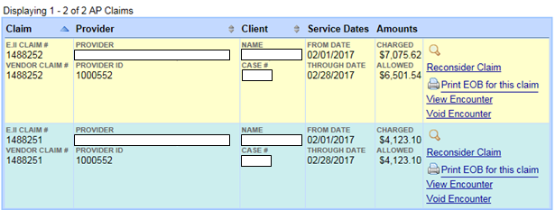

H0043 Site Plan Vs H2015 Site Plan Reimbursement
H0043 Site Plan:
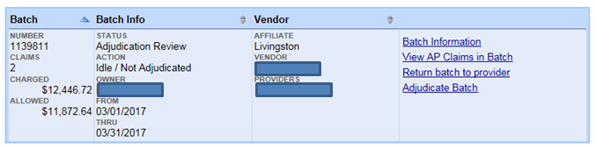
H2015 Site Plan:
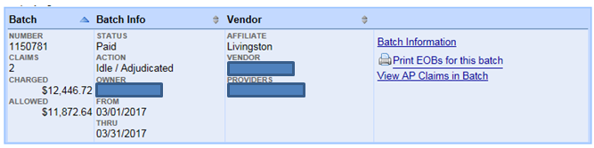
Difference between charged and allowed is any home help deduction (at CMH rate) and/or errors on claim.
H0043 Home Help Reduction:
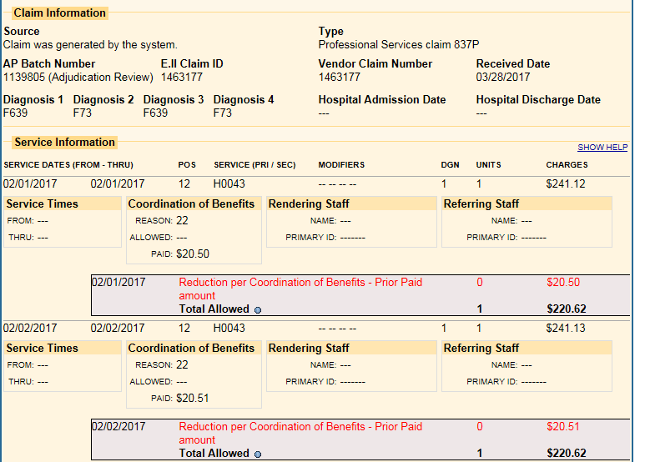

H2015 Home Help Reduction:
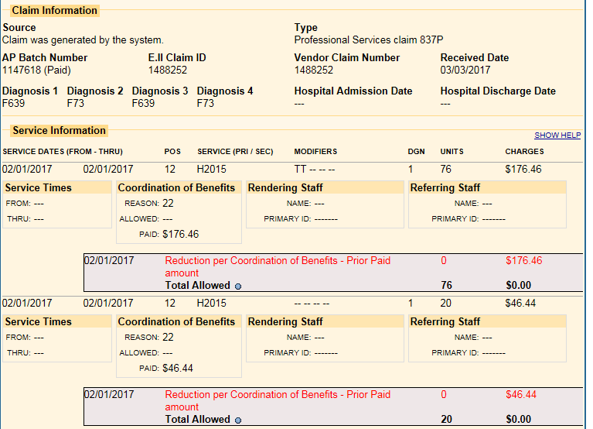

CMHSP Claims Payment
Claims payment is no different than all other CMHSP authorized services and are paid on a unit by unit basis.

Direct Authorization for H2015

What’s New in Direct Authorization H2015 CLS (July 1, 2017)
For CMHSPs:
No substantial changes
For Providers:
No substantial changes

Quick Links
Quick Link to CMHSP Provider Management Staff Section for Directly Authorized H2015
Quick Link to CMHSP Authorizing Staff Section for Directly Authorized H2015
Quick Link to Provider Section for Directly Authorized H2015
Quick Link to CMHSP Claims Payment Staff Section for Directly Authorized H2015

CMHSP Setup

CMHSP Fee Schedule Setup Guide
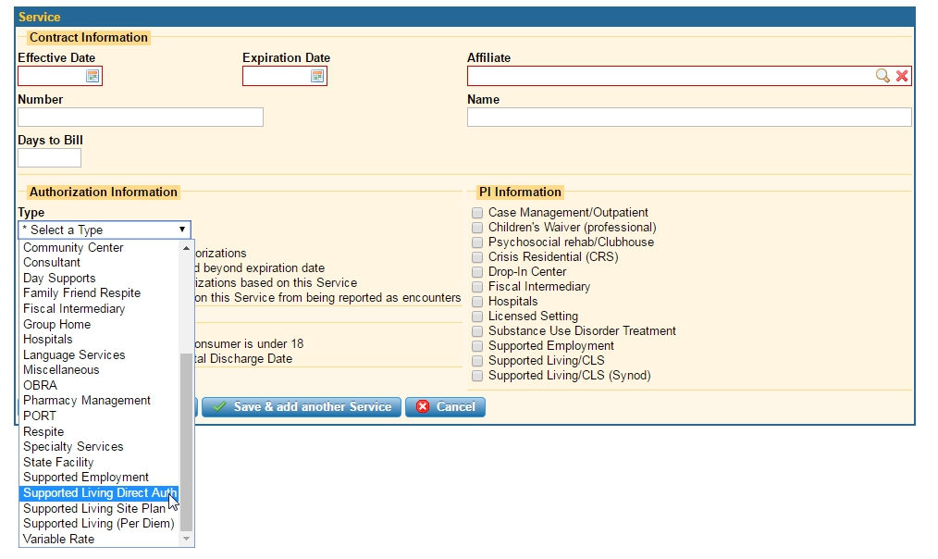
Fee-schedules should be setup within the “Supported Living Direct Auth” service contract type within the EHR.
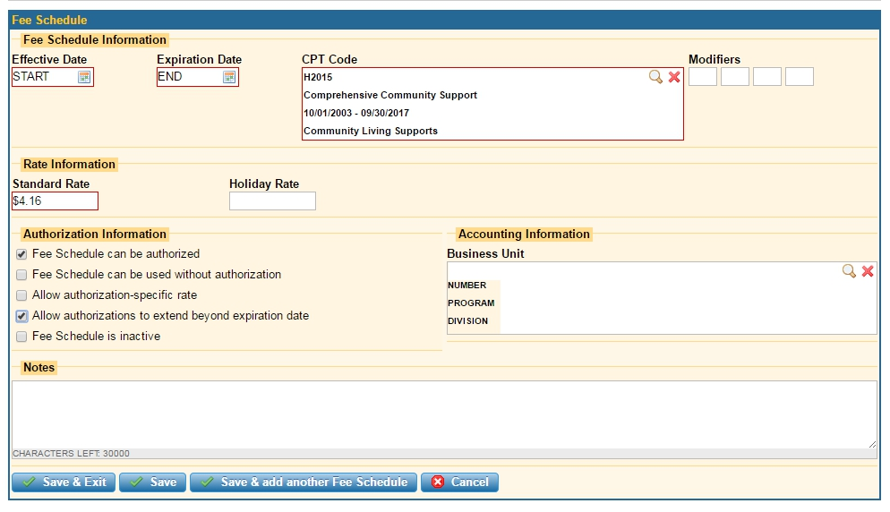

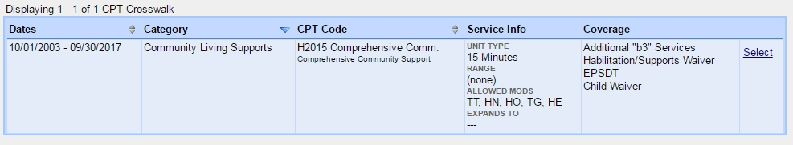

CMHSP Authorization Guide
Authorizations for directly authorized CLS service are no different than any other service authorization within the E.II EHR.

Network Provider Guide
Providers submit claims no different than all other service claims that are paid on a unit by unit basis.

CMHSP Claims Payment
Claims payment is no different than all other CMHSP authorized services and are paid on a unit by unit basis.

Direct Authorization for H0043

What’s New in Direct Authorization H2015 CLS (July 1, 2017)
For CMHSPs:
No changes
For Providers:
No changes

Quick Links
Quick Link to CMHSP Provider Management Staff Section for Directly Authorized H0043
Quick Link to CMHSP Authorizing Staff Section for Directly Authorized H0043
Quick Link to Provider Section for Directly Authorized H0043
Quick Link to CMHSP Claims Payment Staff for Directly Authorized H0043

CMHSP Fee Schedule Setup Guide
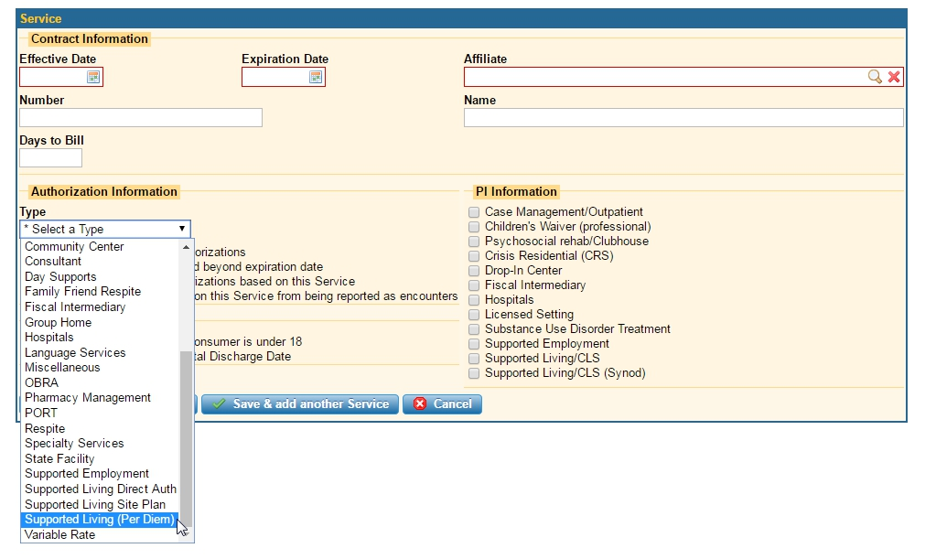
Directly authorized H0043 CLS should be setup within the Supported Living (Per Diem) contract type.
Fee schedules for directly authorized H0043:
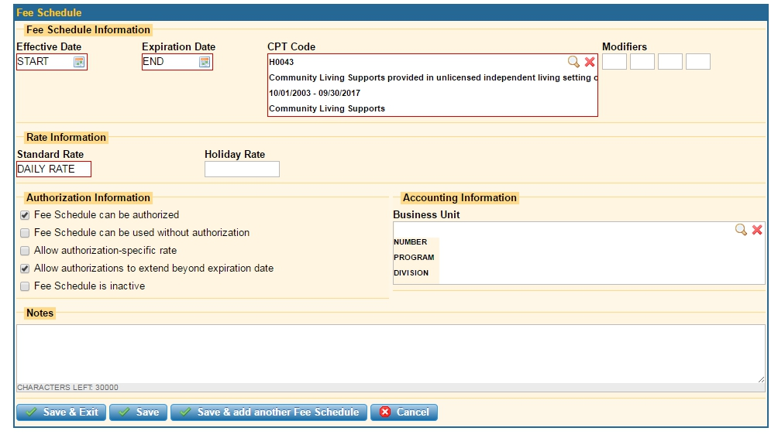

CMHSP Authorization Guide
Authorizations for directly authorized CLS service are no different than any other service authorization within the E.II EHR.

Network Provider Guide
Providers submit claims no different than all other service claims that are paid on a unit by unit basis.

CMHSP Claims Payment
Claims payment is no different than all other CMHSP authorized services and are paid on a unit by unit basis.

Appendix A: General Information on Community Living Supports

Community Living Supports Definition
Community Living Supports are used to increase or maintain personal self-sufficiency, facilitating an individual’s achievement of his goals of community inclusion and participation, independence or productivity. The supports may be provided in the participant’s residence or in community settings (including, but not limited to, libraries, city pools, camps, etc.).
Coverage includes:
- Assisting (that exceeds state plan for adults), prompting, reminding, cueing, observing, guiding and/or training in the following activities:
  - meal preparation
  - laundry
  - routine, seasonal, and heavy household care and maintenance
  - activities of daily living (e.g., bathing, eating, dressing, personal hygiene)
  - shopping for food and other necessities of daily living
CLS services may not supplant services otherwise available to the beneficiary through a local educational agency under the Individuals with Disabilities Education Act (IDEA) or the Rehabilitation Act of 1973 or state plan services, e.g., Personal Care (assistance with ADLs in a certified specialized residential setting) and Home Help or Expanded Home Help (assistance in the individual’s own, unlicensed home with meal preparation, laundry, routine household care and maintenance, activities of daily living and shopping). If such assistance appears to be needed, the beneficiary must request Home Help and, if necessary, Expanded Home Help from MDHHS. CLS may be used for those activities while the beneficiary awaits determination by MDHHS of the amount, scope and duration of Home Help or Expanded Home Help. If the beneficiary requests it, the PIHP case manager or supports coordinator must assist him/her in requesting Home Help or in filling out and sending a request for Fair Hearing when the beneficiary believes that the MDHHS authorization of amount, scope and duration of Home Help does not appear to reflect the beneficiary’s needs based on the findings of the MDHHS assessment.
- Staff assistance, support and/or training with activities such as:
  - money management
  - non-medical care (not requiring nurse or physician intervention)
  - socialization and relationship building
  - transportation from the beneficiary’s residence to community activities, among community activities, and from the community activities back to the beneficiary’s residence (transportation to and from medical appointments is excluded)
  - participation in regular community activities and recreation opportunities (e.g., attending classes, movies, concerts and events in a park; volunteering; voting)
  - attendance at medical appointments
  - acquiring or procuring goods, other than those listed under shopping, and non-medical services
- Reminding, observing and/or monitoring of medication administration
- Staff assistance with preserving the health and safety of the individual in order that he/she may reside or be supported in the most integrated, independent community setting.
CLS may be provided in a licensed specialized residential setting as a complement to, and in conjunction with, state plan coverage Personal Care in Specialized Residential Settings. Transportation to medical appointments is covered by Medicaid through MDHHS or the Medicaid Health Plan. Payment for CLS services may not be made, directly or indirectly, to responsible relatives (i.e., spouses, or parents of minor children), or guardian of the beneficiary receiving community living supports.
CLS assistance with meal preparation, laundry, routine household care and maintenance, activities of daily living and/or shopping may be used to complement Home Help or Expanded Home Help services when the individual’s needs for this assistance have been officially determined to exceed the DHS’s allowable parameters. CLS may also be used for those activities while the beneficiary awaits the decision from a Fair Hearing of the appeal of a MDHHS decision. Reminding, observing, guiding, and/or training of these activities are CLS coverages that do not supplant Home Help or Expanded Home Help.
Community Living Supports (CLS) provides support to a beneficiary younger than 18, and the family in the care of their child, while facilitating the child’s independence and integration into the community. This service provides skill development related to activities of daily living, such as bathing, eating, dressing, personal hygiene, household chores and safety skills; and skill development to achieve or maintain mobility, sensory motor, communication, socialization and relationship-building skills, and participation in leisure and community activities. These supports must be provided directly to, or on behalf of, the child. These supports may serve to reinforce skills or lessons taught in school, therapy, or other settings. For children and adults up to age 26 who are enrolled in school, CLS services are not intended to supplant services provided in school or other settings or to be provided during the times when the child or adult would typically be in school but for the parent’s choice to home-school.

Reference:
April 1, 2017 Medicaid Provider Manual

Appendix B. Old Site Plan Document Blank
LINK TO PAGE HOSTING THIS DOCUMENT
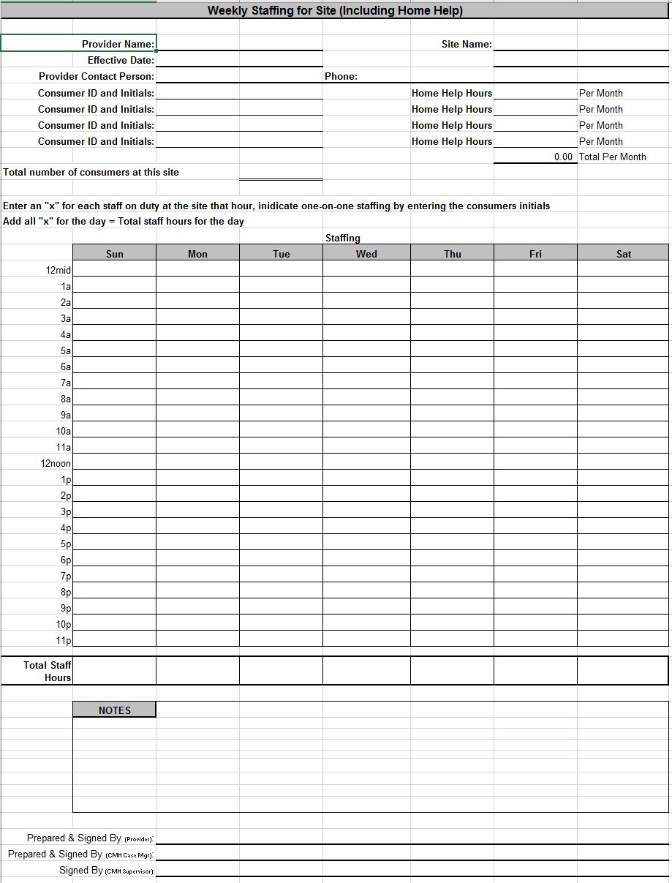

Appendix C. New Site Plan Document
LINK TO PAGE HOSTING THIS DOCUMENT 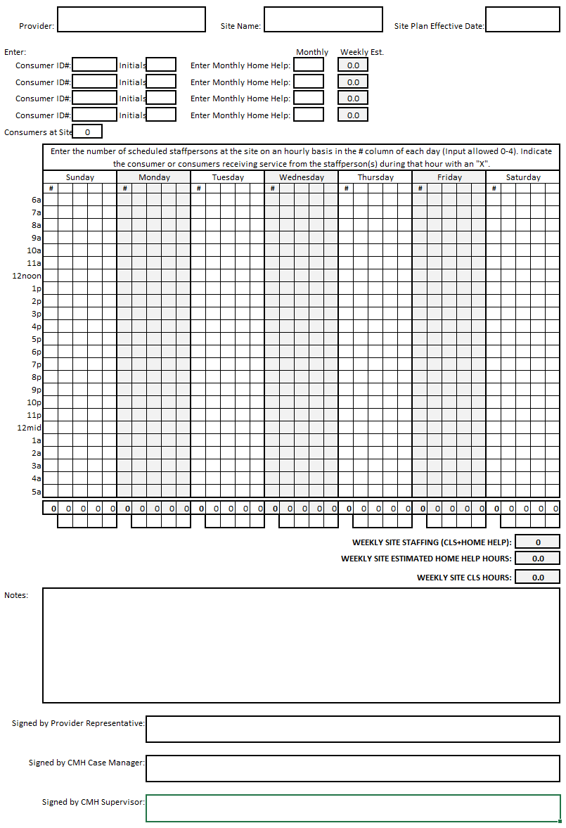

Appendix D. Site Reimbursement Estimator
LINK TO PAGE HOSTING THIS DOCUMENT
